**Instruction guide to running Sample code for Aequilibrium’s project**

(Please note for this instruction guide I am only considering Eclipse/Intellij as the preferred IDE since those are the ones mostly used for Selenium/Appium Projects. For any other IDE guides please let me know and I can provide a detailed guide)

1. **Prerequisites**
2. **To execute this project in Eclipse/IntelliJ IDE please make sure you have Maven and TestNG configured with your preferred IDE.**

**Guide links to setup Maven and TestNG can be found below**

1. Maven with Eclipse - <https://www.toolsqa.com/java/maven/how-to-install-maven-eclipse-ide/>
2. TestNG with Eclipse - <https://www.toolsqa.com/selenium-webdriver/install-testng/>
3. Maven with CMD - <https://www.toolsqa.com/java/maven/create-new-maven-project/>
4. Maven with Intellij - <https://javacord.org/wiki/getting-started/intellij-maven/>
5. TestNG with Intellij - <https://testng.org/doc/idea.html>
6. **Java 8 must be installed on your windows/mac systems for executing this project in Eclipse/IntelliJ IDE – Guides can be found below**
   1. **For Windows -** <https://java.com/en/download/help/windows_manual_download.xml>
   2. **For Mac -** <https://java.com/en/download/help/mac_install.xml>
7. **If installing Eclipse make sure to install TestNG by going in Eclipse Menubar to Help > Marketplace > Searching for TestNG > Click install**

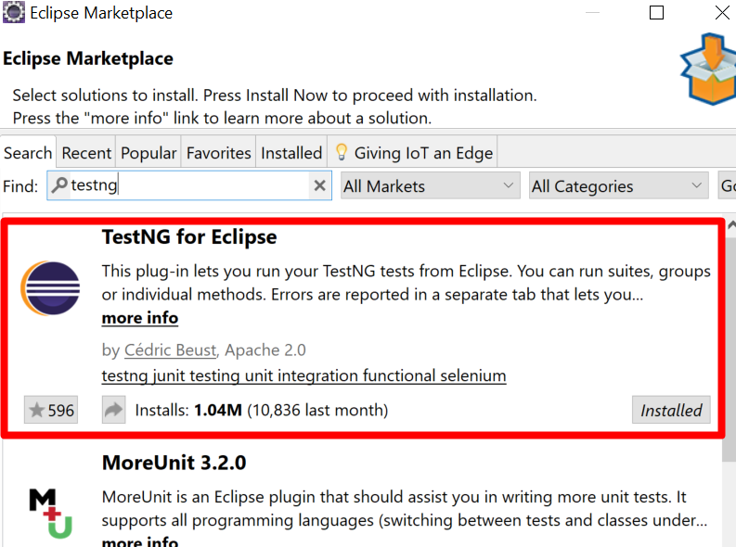

1. **Make sure you have latest versions of Chrome and Firefox installed**
2. **Download the latest Chromedriver and Firefox’s geckodriver and save it in a folder on your local drive.**
3. **Configure the code in your baseclass file after importing the tests to the folder you saved your Chromedriver and Geckodriver files as configured in the screenshot below**

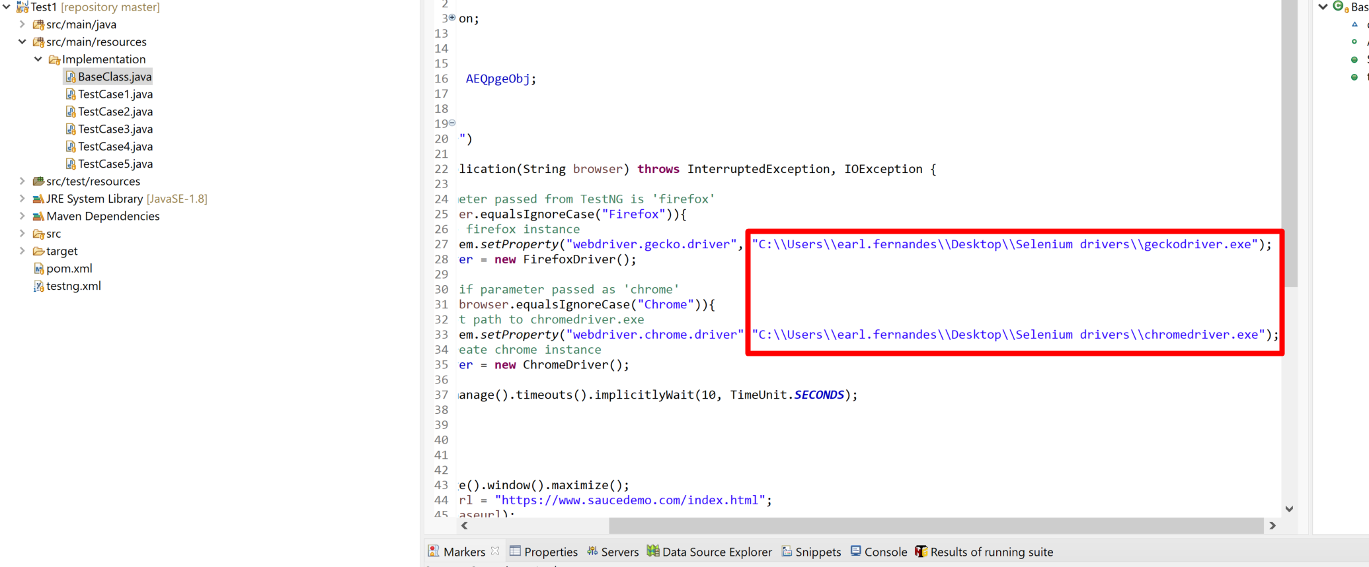

1. **Configuring the Tests**
   1. **You must pull the code from the Github public repository (**https://github.com/eferna5/Aequilibrium.git) **and import the settings for a Maven Project (**into your preferred IDE – Guides for importing to different IDEs can be found below
      1. **IntelliJ -** <https://intellij-support.jetbrains.com/hc/en-us/community/posts/206602645-How-to-pull-a-project-from-Git>
      2. **Eclipse -** <https://github.com/collab-uniba/socialcde4eclipse/wiki/How-to-import-a-GitHub-project-into-Eclipse>

**Features that are covered in this test**

1. **Page object Model shows how the tests can be organized well using Pagefactory for initiating elements in a separate class file using Java’s oops concept of Abstraction.**
2. **Test is run on Test site provided in instructions and covering the first 5 test cases in the Testcases.txt file also provided in the github project.**
3. **Running the test**
   1. **Simply right click on TestNG.xml and run as TestNG suite**
4. **To view results go to Test Output folder in the project and open index.html file in a web browser, you shall see the testNG results once test has ended.**